# Database Basics MS SQL Exam – 8 April 2021

Submit your solutions in the SoftUni Judge system at [Judge](https://judge.softuni.org/Contests/2866/Databases-MSSQL-Server-Retake-Exam-8-April-2021)

# Service

The city mayor, came up with the idea to create an online platform where all the citizens can **report about different problems** and a special organization will work to resolve all the incoming reports. This organization has a few **departments each of which is responsible for a set of problem's categories** in which **users can submit a report**. In each department there are employees who get assigned to a report. Of course, this huge platform needs a reliable database to store and process the information and the mayor has asked for the best specialist in this area. That's why you got chosen! Congratulations and good luck!

# Section 1. DDL (30 pts)

You have been given the E/R Diagram of the Report Service:

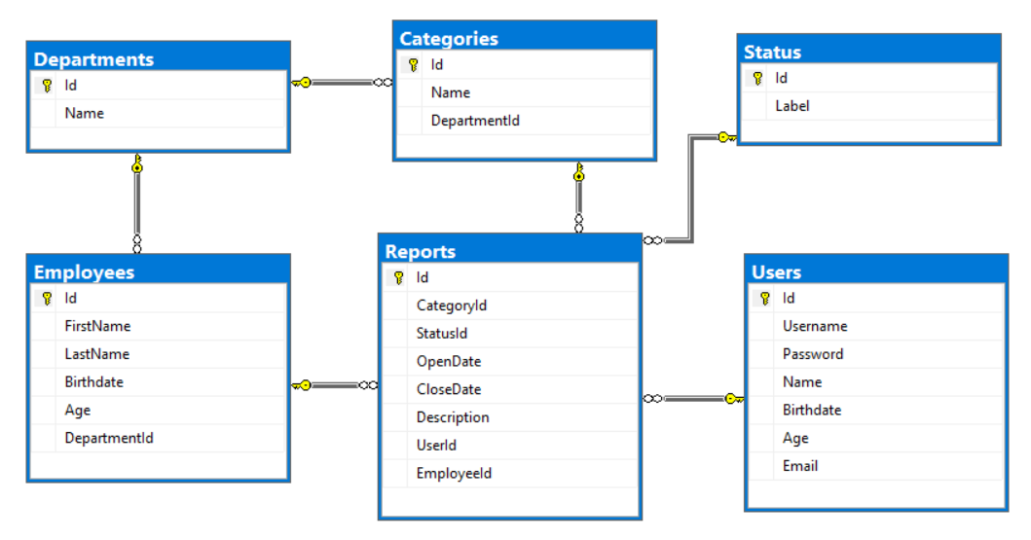

Create a database called Service. You need to create **6 tables**:

* Users - contains information about the people who submist reports;
* Reports **- contains information about the problems;**
* Employees - contains information about the employees;
* Departments - contains information about the departments;
* Categories - contains information about categories of the reports;
* Status- contains information about the possible status.

**NOTE: Please keep in mind that in case you have to work with a date, you have to use the exact same data type, described in the models tables. For example, data type Date means that you have to use Date, DateTime means that you have to use DateTime. If you don't use the correct type, the Judge system won't accept your submission as correct.**

**NOTE: Keep in mind that Judge doesn't accept "ALTER" statement and square brackets naming (when the names are not keywords).**

You have been tasked to create the tables in the database by the following models:

### Users

|  |  |  |
| --- | --- | --- |
| **Column Name** | **Data Type** | **Constraints** |
| **Id** | **Integer** from **0** to **2,147,483,647** | **Unique** table identificator, **Identity** |
| **Username** | **String** up to **30** symbols | **Unique** for each user, NULLis **NOT** permitted |
| **Password** | **String** up to **50** symbols | NULLis **NOT** permitted |
| **Name** | **String** up to **50** symbols | NULLispermitted |
| **Birthdate** | Date **with time** | NULLispermitted |
| **Age** | **Integer** from **0** to **2,147,483,647** | In range between **14** and **110 (inclusive)** |
| **Email** | **String** up to **50** symbols | NULLis **NOT** permitted |

### Departments

|  |  |  |
| --- | --- | --- |
| **Column Name** | **Data Type** | **Constraints** |
| **Id** | **Integer** from **0** to **2,147,483,647** | **Unique** table identificator, **Identity** |
| **Name** | **String** up to **50** symbols | NULLis **NOT** permitted |

### Employees

|  |  |  |
| --- | --- | --- |
| **Column Name** | **Data Type** | **Constraints** |
| **Id** | **Integer** from **0** to **2,147,483,647** | **Unique** table identificator, **Identity** |
| **FirstName** | **String** up to **25** symbols | NULLispermitted |
| **LastName** | **String** up to **25** symbols | NULLispermitted |
| **Birthdate** | Date **with time** | NULLispermitted |
| **Age** | **Integer** from **0** to **2,147,483,647** | In range between **18** and **110 (inclusive)** |
| **DepartmentId** | **Integer** from **0** to **2,147,483,647** | Relationship with table Departments |

### Categories

|  |  |  |
| --- | --- | --- |
| **Column Name** | **Data Type** | **Constraints** |
| **Id** | **Integer** from **0** to **2,147,483,647** | **Unique** table identificator, **Identity** |
| **Name** | **String** up to **50** symbols | NULLis **NOT** permitted |
| **DepartmentId** | **Integer** from **0** to **2,147,483,647** | Relationship with table Departments. NULLis **NOT** permitted |

### Status

|  |  |  |
| --- | --- | --- |
| **Column Name** | **Data Type** | **Constraints** |
| **Id** | **Integer** from **0** to **2,147,483,647** | **Unique** table identificator, **Identity** |
| **Label** | **String** up to **20** symbols | NULLis **NOT** permitted |

### Reports

|  |  |  |
| --- | --- | --- |
| **Column Name** | **Data Type** | **Constraints** |
| **Id** | **Integer** from **0** to **2,147,483,647** | **Unique** table identificator, **Identity** |
| **CategoryId** | **Integer** from **0** to **2,147,483,647** | Relationship with table Categories. NULLis **NOT** permitted |
| **StatusId** | **Integer** from **0** to **2,147,483,647** | Relationship with table Status. NULLis **NOT** permitted |
| **OpenDate** | Date **with time** | NULLis **NOT** permitted |
| **CloseDate** | Date **with time** | NULLis permitted |
| **Description** | **String** up to **200** symbols | NULLis **NOT** permitted |
| **UserId** | **Integer** from **0** to **2,147,483,647** | Relationship with table Users. NULLis **NOT** permitted |
| **EmployeeId** | **Integer** from **0** to **2,147,483,647** | Relationship with table Employees |

## Table design

Submit all of your **CREATE statements** to Judge.

# Section 2. DML (10 pts)

**Before you start you have to import "DataSet-Service.sql". If you have created the structure correctly the data should be successfully inserted.**

In this section, you have to do some data manipulations:

## Insert

Let's **insert** some sample data into the database. Write a query to add the following records into the corresponding tables. All Id's should be auto-generated.

****Employees****

|  |  |  |  |
| --- | --- | --- | --- |
| **FirstName** | **LastName** | **Birthdate** | **DepartmentId** |
| Marlo | O'Malley | 1958-9-21 | 1 |
| Niki | Stanaghan | 1969-11-26 | 4 |
| Ayrton | Senna | 1960-03-21 | 9 |
| Ronnie | Peterson | 1944-02-14 | 9 |
| Giovanna | Amati | 1959-07-20 | 5 |

****Reports****

|  |  |  |  |  |  |  |
| --- | --- | --- | --- | --- | --- | --- |
| **CategoryId** | **StatusId** | **OpenDate** | **CloseDate** | **Description** | **UserId** | **EmployeeId** |
| 1 | 1 | 2017-04-13 |  | Stuck Road on Str.133 | 6 | 2 |
| 6 | 3 | 2015-09-05 | 2015-12-06 | Charity trail running | 3 | 5 |
| 14 | 2 | 2015-09-07 |  | Falling bricks on Str.58 | 5 | 2 |
| 4 | 3 | 2017-07-03 | 2017-07-06 | Cut off streetlight on Str.11 | 1 | 1 |

## Update

Update the **CloseDate** with the current date of all reports, which don't have **CloseDate**.

## Delete

Delete **all reports** who have a **Status** **4**.

# Section 3. Querying (40 pts)

**You need to start with a fresh dataset, so recreate your DB and import the sample data again ("DataSet-Service.sql").**

## Unassigned Reports

Find all **reports** that **don't** have an **assigned employee**. **Order** the results by OpenDate in **ascending** order, then by Description **ascending**. **OpenDate** must be in format - **'dd-MM-yyyy'**

### Example

|  |  |
| --- | --- |
| **Description** | **OpenDate** |
| Art exhibition on July 24 | 17-12-2014 |
| Stuck Road on Str.133 | 20-06-2015 |
| Burned facade on Str.560 | 26-08-2015 |

## Reports & Categories

Select all **descriptions** from reports, which have **category**. Order them by description (**ascending**) then by category name (**ascending**).

### Example

|  |  |
| --- | --- |
| **Description** | **CategoryName** |
| 162 kg plastic for recycling. | Green Areas |
| 246 kg plastic for recycling. | Snow Removal |
| 366 kg plastic for recycling. | Recycling |

## Most Reported Category

Select the **top 5 most reported categories** and **order** them **by** the number of **reports** **per category** in **descending** order and then **alphabetically** by name.

### Example

|  |  |
| --- | --- |
| **CategoryName** | **ReportsNumber** |
| Recycling | 8 |
| Snow Removal | 5 |
| Streetlight | 4 |

## Birthday Report

Select the user's **username** and **category name** in all **reports** in which **users** have submitted a report **on their birthday**. **Order** them by **username** (**ascending**)and then by **category name** (**ascending**).

### Example

|  |  |
| --- | --- |
| **Username** | **CategoryName** |
| 5omarkwelleyc | Snow Removal |
| dpennid | Dangerous Trees |
| llankham6 | Homeless Elders |

## Users per Employee

Select **all** **employees** and show how many **unique** users each of them has served to.

Order by **users count** (**descending**) and then by **full** name (**ascending**).

### Example

|  |  |
| --- | --- |
| **FullName** | **UsersCount** |
| Bron Ledur | 3 |
| Adelind Benns | 2 |
| Dick Wentworth | 2 |
| … | … |

## Full Info

Select **all info** for reports along with employee **first name** and **last name** (**concataned with space**), **their** **department name**, **category name**, **report description**, **open date**, **status label** and **name of the user**. Order them by first name (**descending**), last name (**descending**), department (**ascending**), category (**ascending**), description (**ascending**), open date (**ascending**), status (**ascending**) and user (**ascending**).

Date should be in format '**dd.MM.yyyy**'.

If there are empty records, replace them with '**None**'.

### Example

|  |  |  |  |  |  |  |
| --- | --- | --- | --- | --- | --- | --- |
| **Employee** | **Department** | **Category** | **Description** | **OpenDate** | **Status** | **User** |
| Niki Stranaghan | Event Management | Sports Events | Sky Run competition on September 8 | 08.06.2015 | Completed | Emlynn Alliberton |
| Marlo O'Malley | Infrastructure | Streetlight | Fallen streetlight columns on Str.14 | 12.09.2017 | Blocked | Erhart Alpine |
| Leonardo Shopcott | Animals Care | Animal in Danger | Parked car on green area on the sidewalk of Str.74 | 10.11.2016 | In Progress | Jocko Greggor |
| … | …. | … | … | … | … | … |

# Section 4. Programmability (20 pts)

## Hours to Complete

Create a **user defined function** with the name **udf_HoursToComplete**(**@StartDate** **DATETIME, @EndDate** **DATETIME**) that receives a start date and end date and mustreturns the total hours which has been taken for this task. If start date is **null** or end is **null**, return **0**.

### Example usage

|  |
| --- |
| **Query** |
| SELECT dbo.udf_HoursToComplete(OpenDate, CloseDate) AS TotalHours  FROM Reports |
| TotalHours |
| 0 |
| 288 |
| 0 |

## Assign Employee

Create a **stored procedure** with the name **usp_AssignEmployeeToReport**(@E**mployeeId INT**, @**ReportI**d INT) that receives an **employee's Id** and a **report's Id** and assigns the employee to the report **only if** the department of the employee and the department of the report's category are the same. Otherwise throw an **exception** with message: "**Employee doesn't belong to the appropriate department!**".

### Example usage

|  |
| --- |
| **Query** |
| EXEC usp_AssignEmployeeToReport 30, 1 |
| **Response** |
| Employee doesn't belong to the appropriate department! |
| **Query** |
| EXEC usp_AssignEmployeeToReport 17, 2 |
| **Response** |
| (1 row affected) |